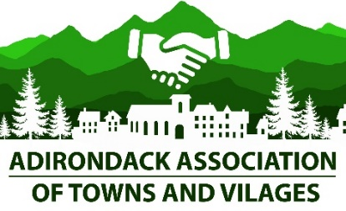

Stephen McNally President Pamela Wright, Administrative Assistant
Shaun Gillilland 1st Vice President William Farber 2nd Vice President Directors At Large:
Gerard Delaney
Regional Directors: Arthur ‘Mo’ Wright
Patricia Littlefield Region A Jean Raymond
Joe Pete Wilson Region B Ronald Robert
Kevin Geraghty Region C Preston Allen
Brian Wells Region D
David Berkstresser Region E Address: PO Box 83, Hadley, NY 12835
Phone: 518-312-6732

RESOLUTION 1 of 2021

IN SUPPORT OF THE DEBAR LODGE LAND EXCHANGE

WHEREAS Debar Lodge and accompanying property was purchased by the State of New York in 1979; and,

WHEREAS the Town of Duane, Franklin County New York has worked diligently to save the Debar Lodge, but has not had the resources to do so; and,

WHEREAS Debar Lodge and associated buildings in the Town of Duane, Franklin County, New York are an important group of architecturally significant buildings listed on the National Register of Historic Places; and,

WHEREAS Debar Lodge has great potential as a cultural, educational and recreational resource for the local area, the Adirondack North Country region, and for the people of New York State and beyond; and,

WHEREAS Debar Lodge is located within the Debar Mountain Wild Forest of the State Forest Preserve and is threatened with demolition under Article 14 of the state constitution; and,

WHEREAS a New York, non-profit educational organization named Debar Pond Institute, is ready, willing and able to enter into a land exchange agreement with the state of New York to trade the state, an equal value of forested acres of land in return for the Debar Lodge, and out buildings, and a small footprint around the buildings to be able to serve the public interest without encroaching on Forest Preserve, and then refurbish the lodge and operate it in the public interest; and

WHEREAS the proposed land exchange would preserve the historic buildings, provide significant public usage and tours, contribute to the local economy, enhance the state Forest Preserve, still allow public recreational access to Debar Pond and the surrounding Forest Preserve, and save the state the cost of demolition, landscaping and any new construction;

NOW, THEREFORE, BE IT RESOLVED, that the Adirondack Association of Towns and Villages, supports the proposed land exchange amendment to the state constitution to preserve Debar Lodge and use in the public interest.

